East Teams (we may bump into) – a cut out and keep guide
Remember – East teams wear their team colours home and away where possible so we won’t always wear white away like in the Midlands

Club | 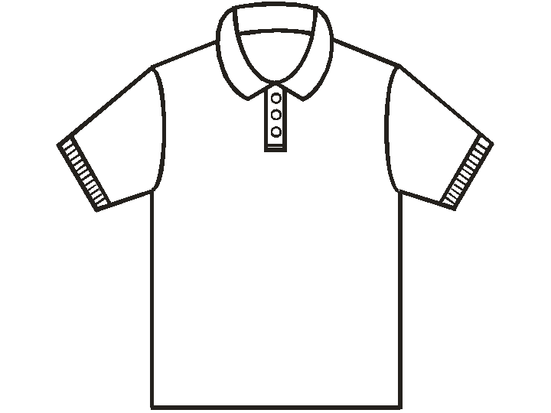 |  | 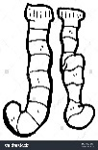 | Home Pitch
Alford and District | Maroon | White | Maroon | Skegness Grammar School
Bourne Deeping | Black | Black | Black | Arthur Mellows Village College, Glinton PE6 7JX
Cambridge City | Red | White | Red | Various
Cambridge Nomads | Blue | White | Blue | Coldhams Common, Whitehall road, Cambs, CB5 8NT
Cambridge South | Purple | Navy | Purple | Long Road Sixth Form College, Cambridge, CB2 8PX
City of Peterborough | Red | Navy | Red | Bretton Gate, Peterborough,PE3 9UZ
Ely City | Green/Yellow | Black | Black | Ely Outdoor Sports Assoc, Downham Rd, Ely CB6 2SH
Horncastle | Gold/Black | Black | Gold | Coronation Walk, Horncastle, LN9 6EB
Leadenham | Black | Black | Black | RAF Cranwell, Sleaford, Lincs NG34 8HB
Long Sutton | Green | White | Green | The Peele Leisure Centre, Little London, Long Sutton PE12 9LF
Louth | White | Black | White | The Pavilion, London Rd, Louth
March | Amber | Black | Amber | Neale-Wade Academy, Wimblington Rd, March PE15 9PX
Spalding | Light Blue/Maroon | White | Light Blue/Maroon | Glen Park, Surfleet
St Ives | Green | Navy | Blue | One Leisure Centre, California Rd, St Ives PE27 6SJ
St Neots | Light Blue | Navy | Light Blue | Longsands College, Longsands Rd, St Neots PE19 1LQ
Wisbech | Red | Black | Red | The Pavilion, Harecroft Rd, Wisbech PE13 1RR

