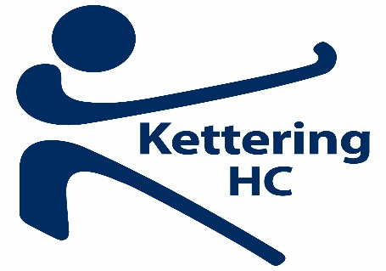

Kettering Hockey Club is delighted to announce that one of its fundraising projects this year is Wren Spinney Community Special School.
25 % percentage of everything we raise as a club will be split between our two charities, Wren Spinney School and Johnny’s Happy Place at the end of the season. It would be great to be able to buy some sports equipment for Wren Spinney.
Wren Spinney is a Community Special School meeting the educational needs of up to 60 pupils with Severe, Profound and Multiple Learning Difficulties, Autism, Visual Impairment, and Multi-Sensory Impairment from 11-18+ years of age.
For more details check out www.wrenspinney.northants.sch.uk

