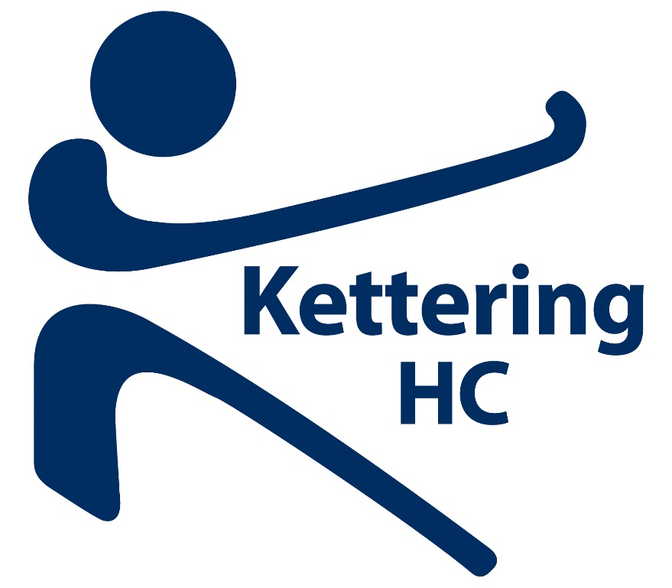

Kettering Hockey Club
  - New Player PAck
All the details you need when you join KHC | 2018/19

Membership
Kettering Hockey Club offer a variety of playing options.
Subscriptions: -
Hockey Membership Category | Subscription payable
Adult - Senior | £100
Adult – over 60 | £50
Junior - Year 9 and above | £45
Adult - Still in full time education | £45
Junior – Year 8 and below | £35
Social Membership | £10
Subscriptions to be paid by End of October or monthly by arrangement with Tom Sellers.
Social membership gives you access to the Clubhouse but NO voting rights at an AGM or EGM. That privilege is reserved for fully paid up Club members.
Match Fees: -
Playing Category | Match Fee payable for League and Cup games
Adult - Senior | £10
Adult – still in full time education | £5
Junior ( all categories) | £5
Goalkeepers – with own kit | 50% reduction of match fee
Match fees to be paid on day of game. Arrangements can be made for a lump sum payment to cover Subs and match fees with a rebate given at the end of the season for unused monies. Any debts incurred by members must be settled up at the end of the season.
Summer League and Skymoons (our mixed team) match fees are arranged by Team Captains usually to cover costs incurred whilst playing.
The Club also issue a maximum of 5 Associate Memberships of £35 to non-playing Club members. This gives them the opportunity to hold committee positions and have voting rights. These are issued on recommendation of the Executive Committee.
If a club member has any issues regarding hardship they must speak to the Club Treasurer who will make every effort to ensure the member can keep playing.
Membership Fees are due by 1st October.

Training and Playing games

Kettering HC offer training at Bishop Stopford School on Tuesdays and Wednesdays.
The coaching schedule is currently
Tuesday 530 – 630 Under 10s (£2 per session cost)
Tuesday 630 – 730 Under 14s (£2 per session cost)
Tuesday 730 – 830 Ladies 4th team and Junior Girls development (cost included in membership)
Tuesday 730 – 900 Mens 3rds and 4ths (costs included in membership)
Wednesday 600- 700 Ladies 2nds and 3rds (costs included in membership)
Wednesday 645 – 815 Ladies 1sts (costs included in membership)
Wednesday 700 – 900 Mens 1st and 2nds (costs included in membership)

Generally speaking people train with the team they play for but it is not unusual for people to be asked to train with a higher squad to aid their development.
Matches usually take place on Saturdays with Cup games on Sundays. Rearranged League games are generally on Sundays.
Mixed matches are played in the Northants Mixed League and are midweek in Northampton.
Ladies 7 a side is Tuesday nights at Wrenn School, Wellingborough during the summer months.
Kettering Saturday teams currently play in
Ladies 1 | Midlands Div 2 | Mens 1 | East League 3NW
Ladies 2 | Northants Div 1 | Mens 2 | East League 5NW
Ladies 3 | Northants Div 1 | Mens 3 | East League 6NW(S)
Ladies 4 | Northants Div 2 | Mens 4 | East League 6NW(S)

All we ask is that players who wish to play on Saturdays are committed to play as often as possible and will represent whichever team they are selected for.

Other roles

We try to keep an up to date database of our members’ qualifications that relate to hockey.
Do you have a Level 1 Umpiring Qualification?
If you do we’d love to hear from you. As you can imagine putting eight teams out every Saturday takes some organizing and we are always on the look-out for umpires. We also pay out of pocket expenses of £15 a game.
We also have a great deal for our umpires whereby if you umpire ten games you qualify for a free umpiring shirt. Those games may be spread over more than one season. When you do twenty you qualify for another one.
If you don’t want an umpiring shirt but you would rather umpire in a club jacket the club will subsidise your jacket by the cost of a shirt.
Would you like to become an umpire?
Kettering HC will refund the cost of an umpiring course after you have umpired three games. We appreciate that going on courses can be a hassle so we try to arrange to host an umpiring course every couple of years. As we have our own clubhouse we are trying to become a hub centre for hockey in the East Midlands.

Do you have a coaching qualification?
Again, running loads of adult teams and lots of junior sessions we are always on the look-out for coaches. If you have a current coaching qualification and are keen to get involved let the Chair of Senior Performance or Junior Academy Chairperson know. Emails at end of welcome pack. We offer a flat rate expense for coaching.
Would you like to gain a qualification in coaching?
We are always keen to get the right people qualified so we will fund a course to get you qualified. Obviously you will have to use your new found skills to coach sessions at Kettering.
You could be trying to get a Level 2 or attend a Goalkeeping coaching course.

Playing Kit

Kettering has a kit deal with the company Silver FX.
Details can be obtained by visiting our shop on their website (https://www.silverfx.co.uk/category/sports-clubs/kettering-hockey-club/) or accessing the shop through our website.
Buy One Get One Free Offer
As a Club we think it is important to present a professional image when we play and as such offer a great offer to new members only. If you purchase home and away match shirts the Club will refund you the cost of one shirt so it is in effect buy one get one free. This offer only applies on the first shirts you buy.
There are many other items available to buy such as shorts, skirts and socks plus jackets, gilets etc. Some examples are below.

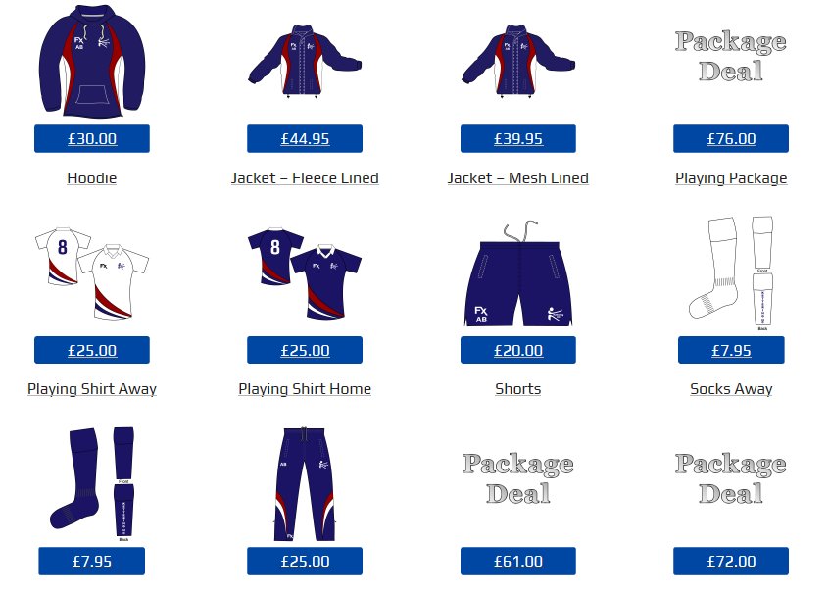

Juniors
Kettering HC has a thriving junior section.
All details are available on our website under Junior Hockey in the Information section.
Club kit is also available for Juniors.
We charge £2 a session for juniors. We make sure all lead coaches are qualified to at least Level 1 standard. Lots of our junior players help out with junior coaching to make sure there is plenty of support for our very young players. There is no real minimum age to start its whenever the child wants to start but that is usually around four years old.
Junior matches are usually played on a Sunday and are central venue. We have great support from our parents and when we host a tournament we hope senior members will help out with umpiring etc.
We have teams that play at Under 8, Under 10, Under 12 and Under 14. The two youngest age groups are mixed gender. Our junior teams regularly represent Northamptonshire at Regional tournaments.
Kettering feed many juniors into the Northants County Hockey system. We also host a Junior Development Centre.
Juniors are eligible to play senior hockey from 13yrs old but we take every care to make sure that junior players are ready to play senior hockey. We occasionally field Under 16 and 18 teams.

Safeguarding
Kettering HC is an accredited England Hockey ClubMark club. As such we take the safeguarding of all our members seriously.
We have a Welfare Officer and Deputy Welfare Officer who both have dedicated email addresses where any concerns can be raised.
We also keep copies of relevant DBS certificates and ensure all safeguarding training is up to date. We aim to get all key personnel to complete EH basic safeguarding training.

Social Media
Kettering HC uses social media to inform members of what is happening, publish match reports, publicise social events etc.
Check us out on
The internet at www.ketteringhockeyclub.co.uk
On Facebook at https://www.facebook.com/ketteringhockeyclub/
On Twitter at @kett_hc
Individual squads often have their own WhatsApp groups to share information about fixtures.

Check our teams out on their respective league websites
Men – www.east-hockey.com
Ladies 1st – www.mrhawl.clubbuzz.co.uk
Ladies 2nd 3rd 4th – www.ncwha.clubbuzz.co.uk
We also use old fashioned print media!! Our match reports are always in the Northants Evening Telegraph

Frequently asked questions
Is there an active social scene at the Hockey Club?
We try to run social events that appeal to a wide range of club members. We have bingo night, Halloween Party, Christmas Party, Quiz night, a Race night and our Awards Dinner at the end of the season. The junior section also go ice skating and host their own awards evening.
Do I need my own insurance?
As a paid up Club Member you are insured for playing and umpiring with Perkins Slade. They are a specialist sports Club insurer. If you would like to see our policy details this can be arranged.
Can I use the Clubhouse at any time?
If it’s open you can use it! You are also able to hire the room for private parties at a reduced cost. See Sue Russell for details.
So, I am also a member of other sections?
Your membership to hockey means you become a member of Kettering Sports Club and affiliated to Hockey. To play cricket, for example, you just need to pay the cricket affiliation (approx. £20). The same applies to archery, rifle and tennis sections. Junior Football is obviously only available to our junior members.
I don’t play but would like to help?
We can always find a job for you. We are always on the lookout for administrators, umpires, coaches whatever. Make us an offer and we will find you a job. The membership at KHC are all very willing with their time but we will never turn anyone away!!
Do you help out in your community?
Every year Kettering HC fundraise for Club funds but also donate 25% of all money raised to two local charities chosen by the committee. 2017/18 it is Johnnys Happy Place and Wren Spinney School (each will receive 12.5% of all our fundraising).

I’m new to the game – how will I get started?
We run Back to Hockey (B2H) sessions in the summer months that are pay as you play and will get you back into the game. You can carry on by training in the winter but will need to become a member. That means you can try out your new skills in matches on Saturday when you think you are ready.
Do you run Veterans teams?
We have successful Veterans teams at Over 35 and 45 for Ladies and Over 50s for men.
Does each team have a coach?
We make sure that every squad has a dedicated coach. These usually come from within the Club but when necessary we have external coaches. We also have occasional guest coaching sessions (for example, our Goalkeepers had a dedicated session in Jan 18 with a high profile external coach). We also invest in our coaches and have arranged a Coach Education session for pre-season 2018/19.
How is the Club organised?
We have an Executive Committee of 7 members (Chair, Vice Chair, Treasurer and Secretary plus the Chairs of our three sub committees) plus our Non-Executive President. Our three sub-committees are Junior Academy (everything to do with Juniors), Senior Performance (everything to do with Senior playing) and the Operations Committee (everything else that makes the Club run!). Each sub committee chair reports directly to the Executive Committee. Meeting minutes are published on the Club website so the running of the Club is as transparent as possible.
Does the Club have a vision for the future?
Kettering HC sees itself as a very progressive Club. We have a five-year Development Plan that is accessible to all members and is updated/reviewed at every Executive Committee meeting. It’s available to view on our website.
How do you keep me informed of things?
We make sure we have an up to date email address for you and the Club uses a Gmail account to keep members aware of what is going on. That is an extra as all the information is on the Club website, twitter account and Facebook.
Can I see what the Club Committees are doing?
We make sure all the minutes of Executive Committee Meetings are published on our website. Our committee are always happy to answer any questions you might have,
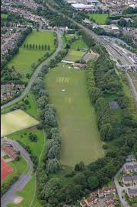

This aerial picture shows Kettering Sports Club. This is where we go for after game teas and social events,
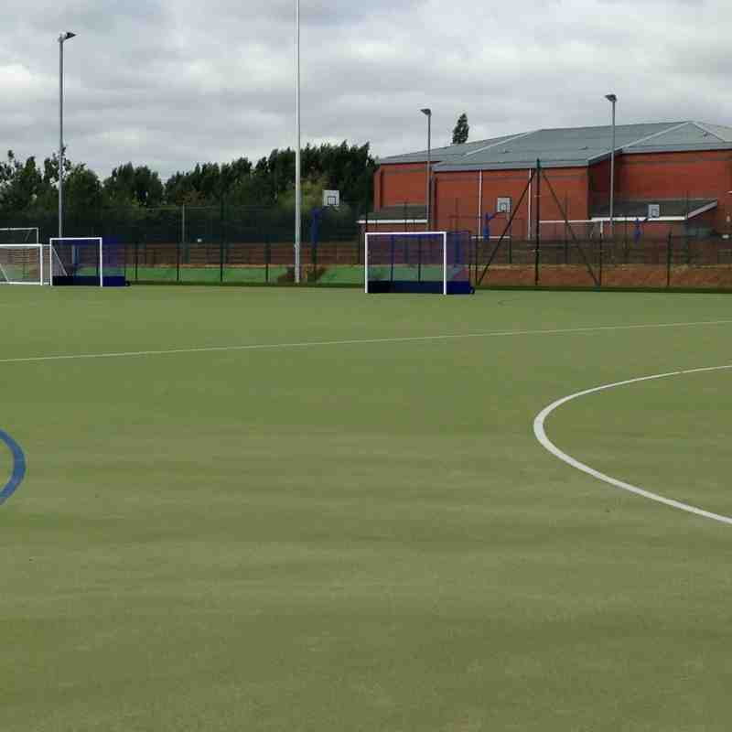
Our home pitch:- Bishop Stopford School. Newly laid in 2017.
Useful Contacts:
Jaime Cox chair@ketteringhockeyclub.co.uk
Liz Randle secretary@ketteringhockeyclub.co.uk
Tom Sellers treasurer@ketteringhockeyclub.co.uk
Barry Coe vicechair@ketteringhockeyclub.co.uk
Webmaster webmaster@ketteringhockeyclub.co.uk
Welfare Officer welfareofficer@ketteringhockeyclub.co.uk

